**CRM Guide: How to Add Rent Receipts**

Banking & Reconciliation → Receivables

*A step-by-step visual guide*

# Overview

This guide explains two methods for recording rent receipts in the CRM:

* Method 1 – Via the Bank Statement (Banking & Reconciliation): Import bank statement transactions and allocate payments directly to tenant accounts.
* Method 2 – Via Receivables (Finance → Receivables): Manually add a receipt from the scheduled receivables list.

Both methods result in the same outcome: a rent receipt being recorded against the correct tenancy reference. Follow the method that matches your workflow.

# Method 1: Bank Statement Allocation

Use this method when you have imported a bank statement and need to match transactions to tenant rent accounts.

**Step 1: Navigate to Banking & Reconciliation**

From the left-hand menu, go to Finance → Banking & Reconciliation. Click on the Bank Statement tab at the top of the page.

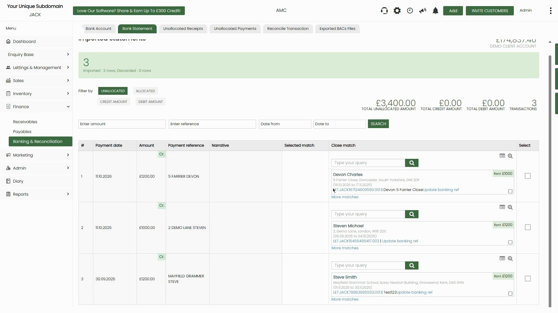

*Figure 1: Bank Statement tab showing imported transactions with suggested matches*

**Step 2: Review Imported Transactions**

The Imported Statements page shows all transactions from the uploaded bank file. Each row displays the payment date, amount, and payment reference. The page is filtered by Unallocated by default — these are payments waiting to be matched.

On the right side, the Close Match column shows automatically suggested tenant matches based on the payment reference and amount. Review each suggestion before proceeding.

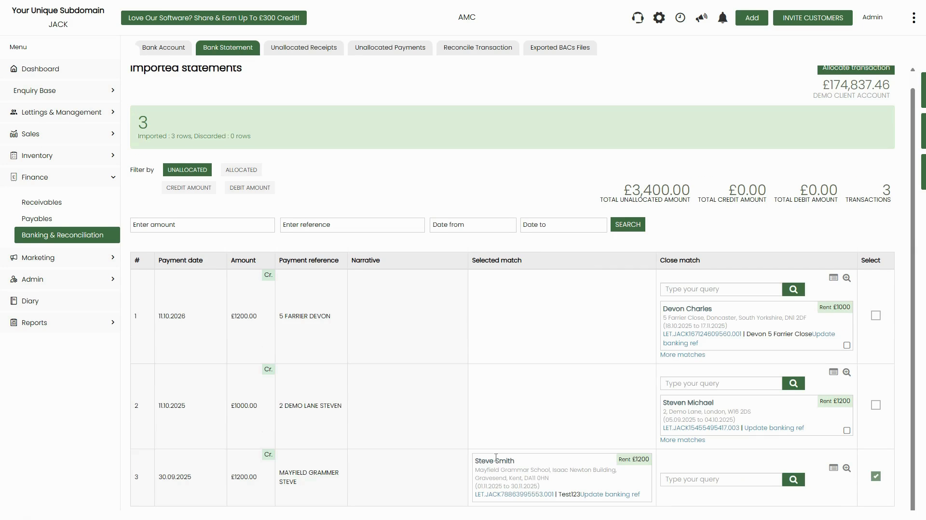

*Figure 2: Transactions list showing three unallocated payments with close match suggestions*

**📌 Note:** Transactions highlighted in green in the 'Select' column are already ticked for allocation. Check the 'Selected match' column to confirm the correct tenant is shown before allocating.

**Step 3: Select Transactions for Allocation**

Tick the checkbox in the Select column on the right for each transaction you wish to allocate. When a tenant match is confirmed in the Selected Match column, the transaction is ready to be processed.

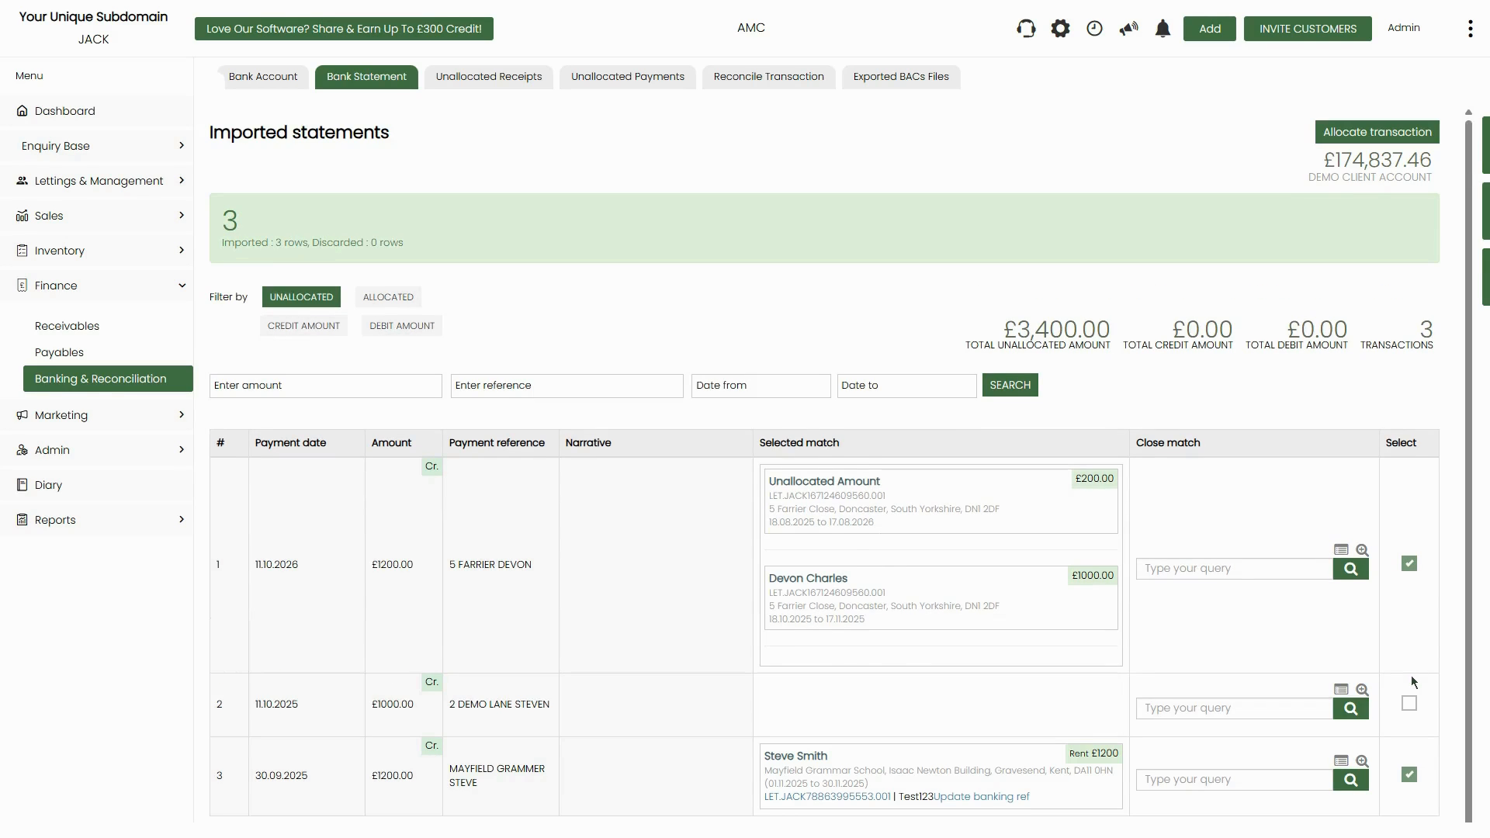

*Figure 3: Transactions with confirmed selected matches — Devon Charles (£1,000) and Steve Smith (£1,200) are ready*

**Step 4: Allocate a Transaction Manually (Find and Allocate)**

For transactions where the system has not automatically matched a tenant, click the magnifying glass / search icon in the Close Match column. This opens the Find and Allocate dialog.

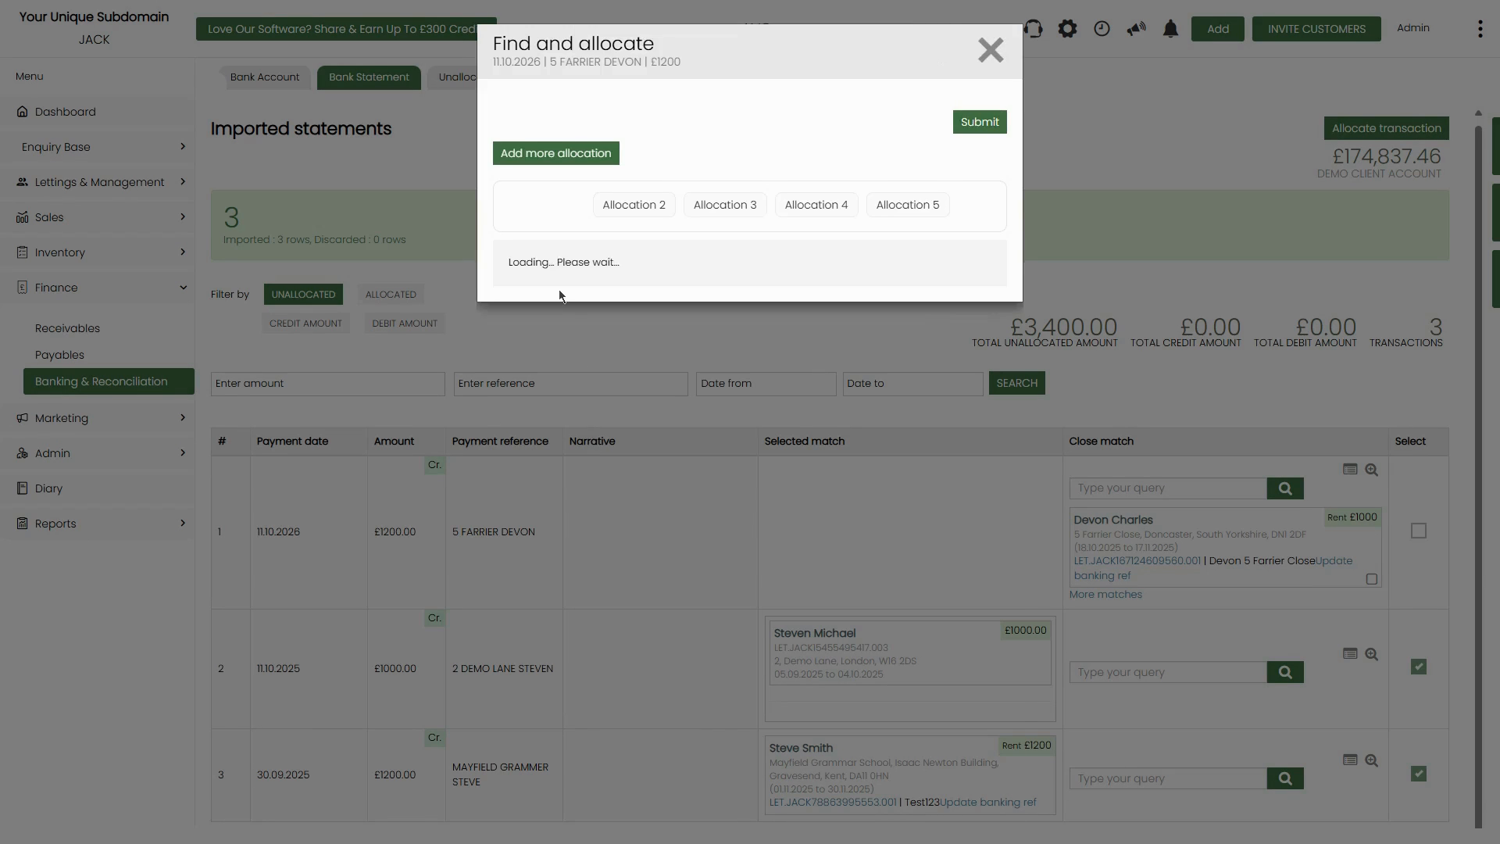

*Figure 4: Find and Allocate dialog — loading tenant data*

Once loaded, the dialog shows the property, letting reference, tenancy period, and a list of outstanding rent periods. Each row shows the Ref, Due Date, Amount Due, Amount Received, and Balance.

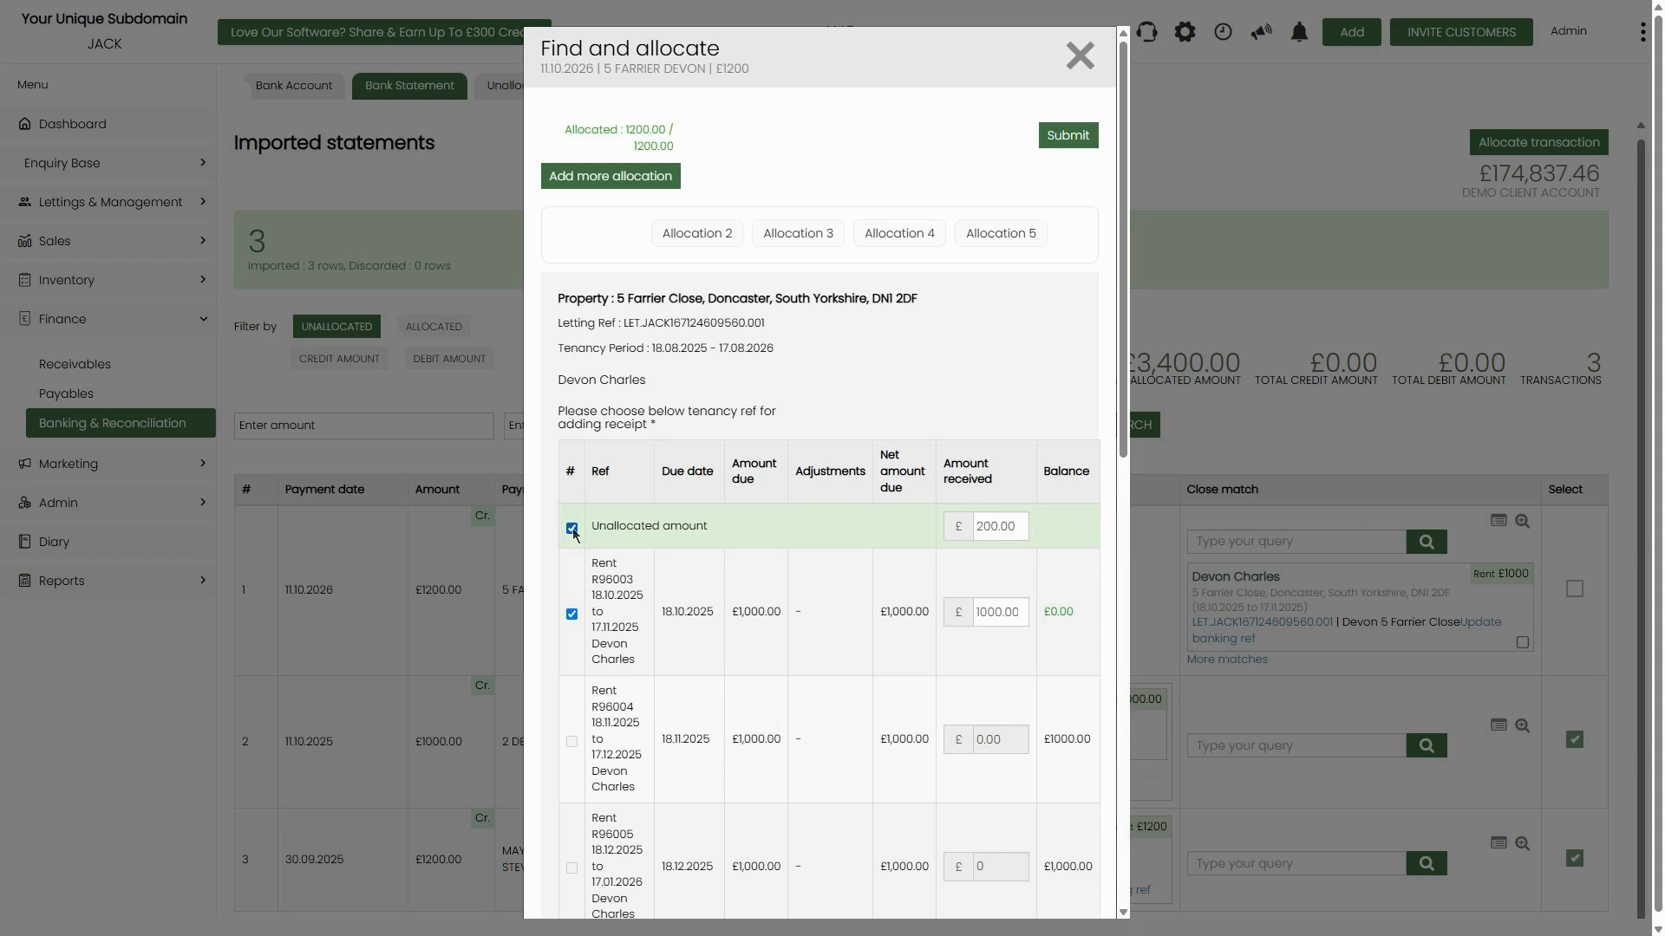

*Figure 5: Find and Allocate dialog — select the correct rent period to allocate against*

Tick the checkbox next to the rent period you wish to allocate the payment to. The system will auto-fill the 'Amount Received' field. Once the allocation is correct (Allocated amount matches the transaction total), click Submit.

**📌 Note:** If a payment is split across multiple rent periods, tick multiple rows. The 'Allocated' counter at the top (e.g. 1200.00 / 1200.00) confirms when the full amount has been assigned.

**Step 5: Handle Unallocated Amounts**

If a payment is larger than a single outstanding rent charge, or if no exact match is found, the system will show an Unallocated Amount entry in the Selected Match column. This represents the surplus payment that has not been applied to a tenancy period.



*Figure 6: Transaction 1 shows both an Unallocated Amount (£200) and Devon Charles (£1,000) in the Selected Match column*

**📌 Note:** An unallocated amount is kept in the system as a credit until it can be manually matched to a future rent period or investigated further.

**Step 6: Search for a Tenant Manually**

If the CRM does not suggest a match, you can search manually using the text search inside the Find and Allocate dialog. Enter the property address or search by Landlord / Tenant name to find the correct letting record.

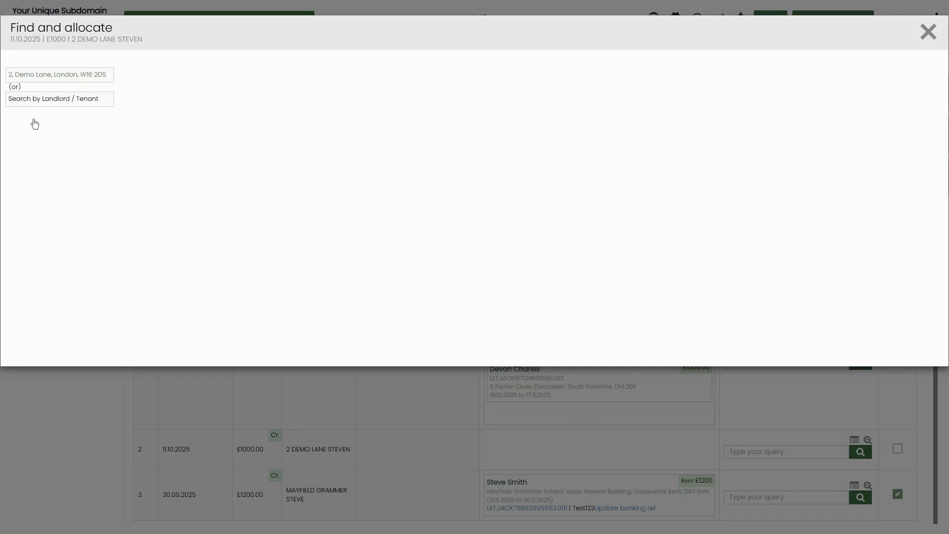

*Figure 7: Manual search inside Find and Allocate — search by address or landlord/tenant name*

**Step 7: Click 'Allocate Transaction' to Process All**

Once all transactions in the list have been matched (shown by green ticks in the Select column), click the green Allocate transaction button in the top-right corner of the page. The system will process all selected allocations at once.

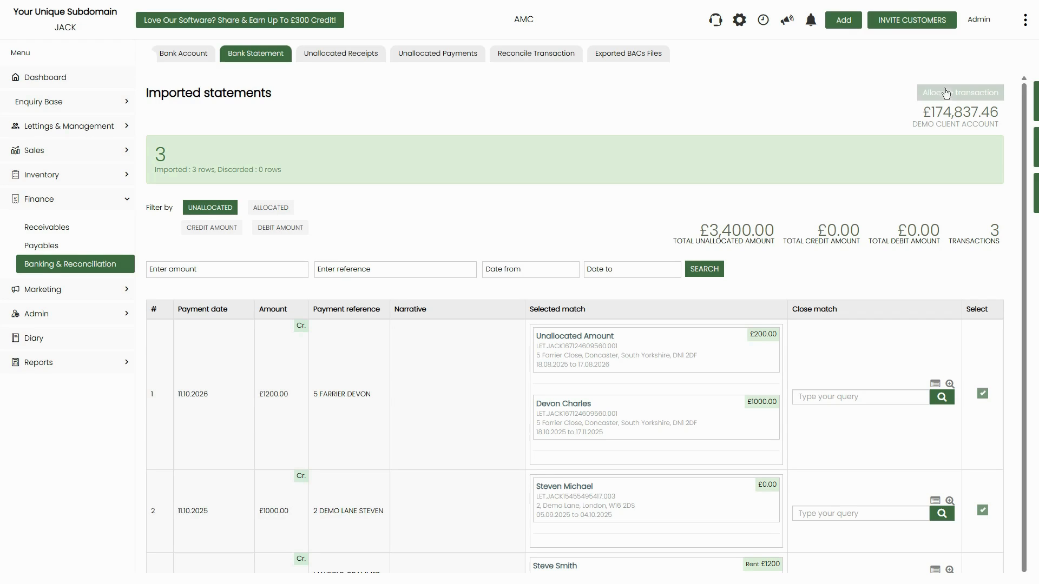

*Figure 8: All three transactions matched and ready — click 'Allocate transaction' button (top right)*

**📌 Note:** The counter in the top-right (e.g. 'Allocating 2 / 3') shows real-time progress as the system processes each transaction. Do not close or refresh the page during this process.

# Method 2: Add Receipt via Receivables

Use this method when you want to manually record a rent payment against a specific tenant from the Receivables schedule, without going through the Bank Statement workflow.

**Step 1: Navigate to Finance → Receivables**

From the left-hand menu, click Finance → Receivables. The Receivables page opens, showing all scheduled receivable items. The page defaults to the Scheduled Receivables tab.

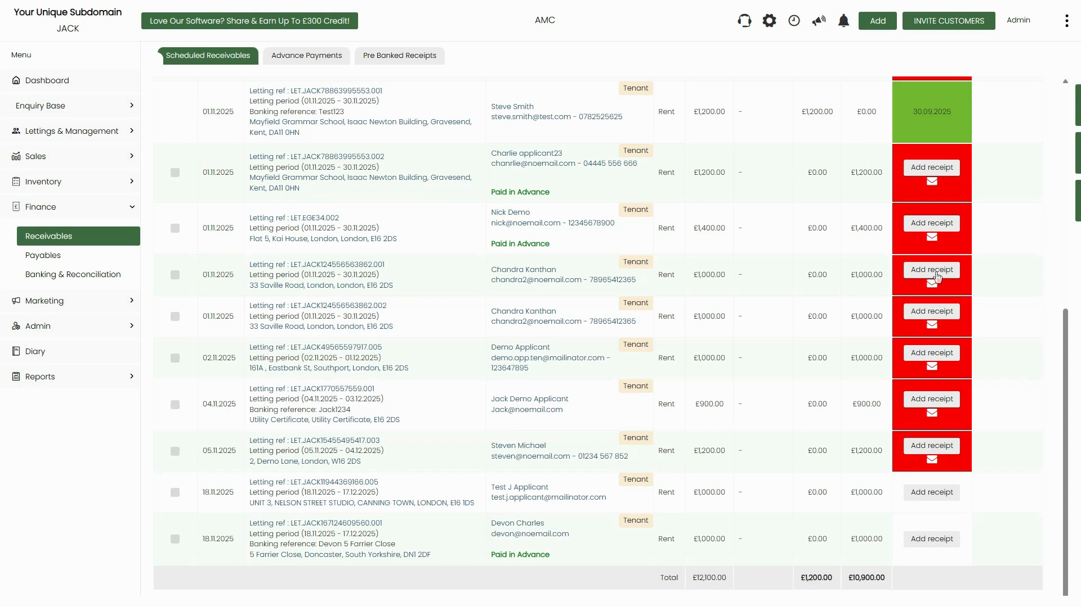

*Figure 9: Receivables page — Scheduled Receivables tab showing all tenants with outstanding rent*

**Step 2: Locate the Tenant and Click 'Add Receipt'**

Scroll through the list to find the relevant tenant and letting reference. Each row shows the due date, letting ref, property address, tenant name, type (Rent/Deposit), amount due, received, and balance. When you find the row you need, click the red Add receipt button on the right.



*Figure 10: Each tenant row has an 'Add receipt' button on the right. Rows already received appear in green.*

**📌 Note:** Rows showing a green date button (e.g. '30.09.2025') indicate payment has already been received and no further action is needed for that period.

**Step 3: Fill in the Add Receipt Form**

Clicking Add receipt opens a dialog. Complete the following fields:

* Receipt types – Select 'Rent' from the dropdown (or Deposit / Fee as applicable).
* Receipt amount – Enter the amount received from the tenant.
* Date received – Enter the date the payment was received.
* Payment method / Source – Select the payment method (e.g. Bank Transfer, Cheque, Cash).
* Account – Select the client account the money was paid into.
* Notes / Bank reference – Optionally enter a bank reference or memo for this payment.

On the right side of the dialog, a table shows all tenancy periods for the letting. Tick the checkbox next to the correct period to allocate the receipt to that rent period.

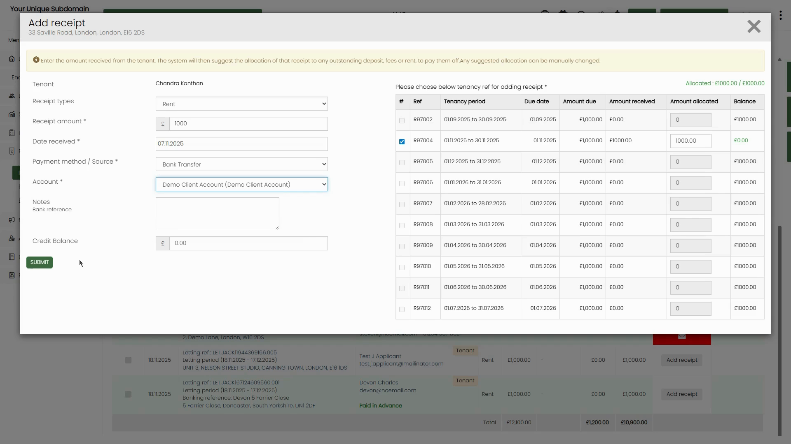

*Figure 11: Add Receipt form — left side for payment details, right side to select tenancy period*

**Step 4: Handle Overpayments (Credit Balance)**

If the receipt amount entered is greater than the balance due for the selected period, the Credit Balance field at the bottom of the form will update automatically to show the surplus amount (e.g. £500.00). This credit is stored against the tenancy and can be applied to future rent periods.

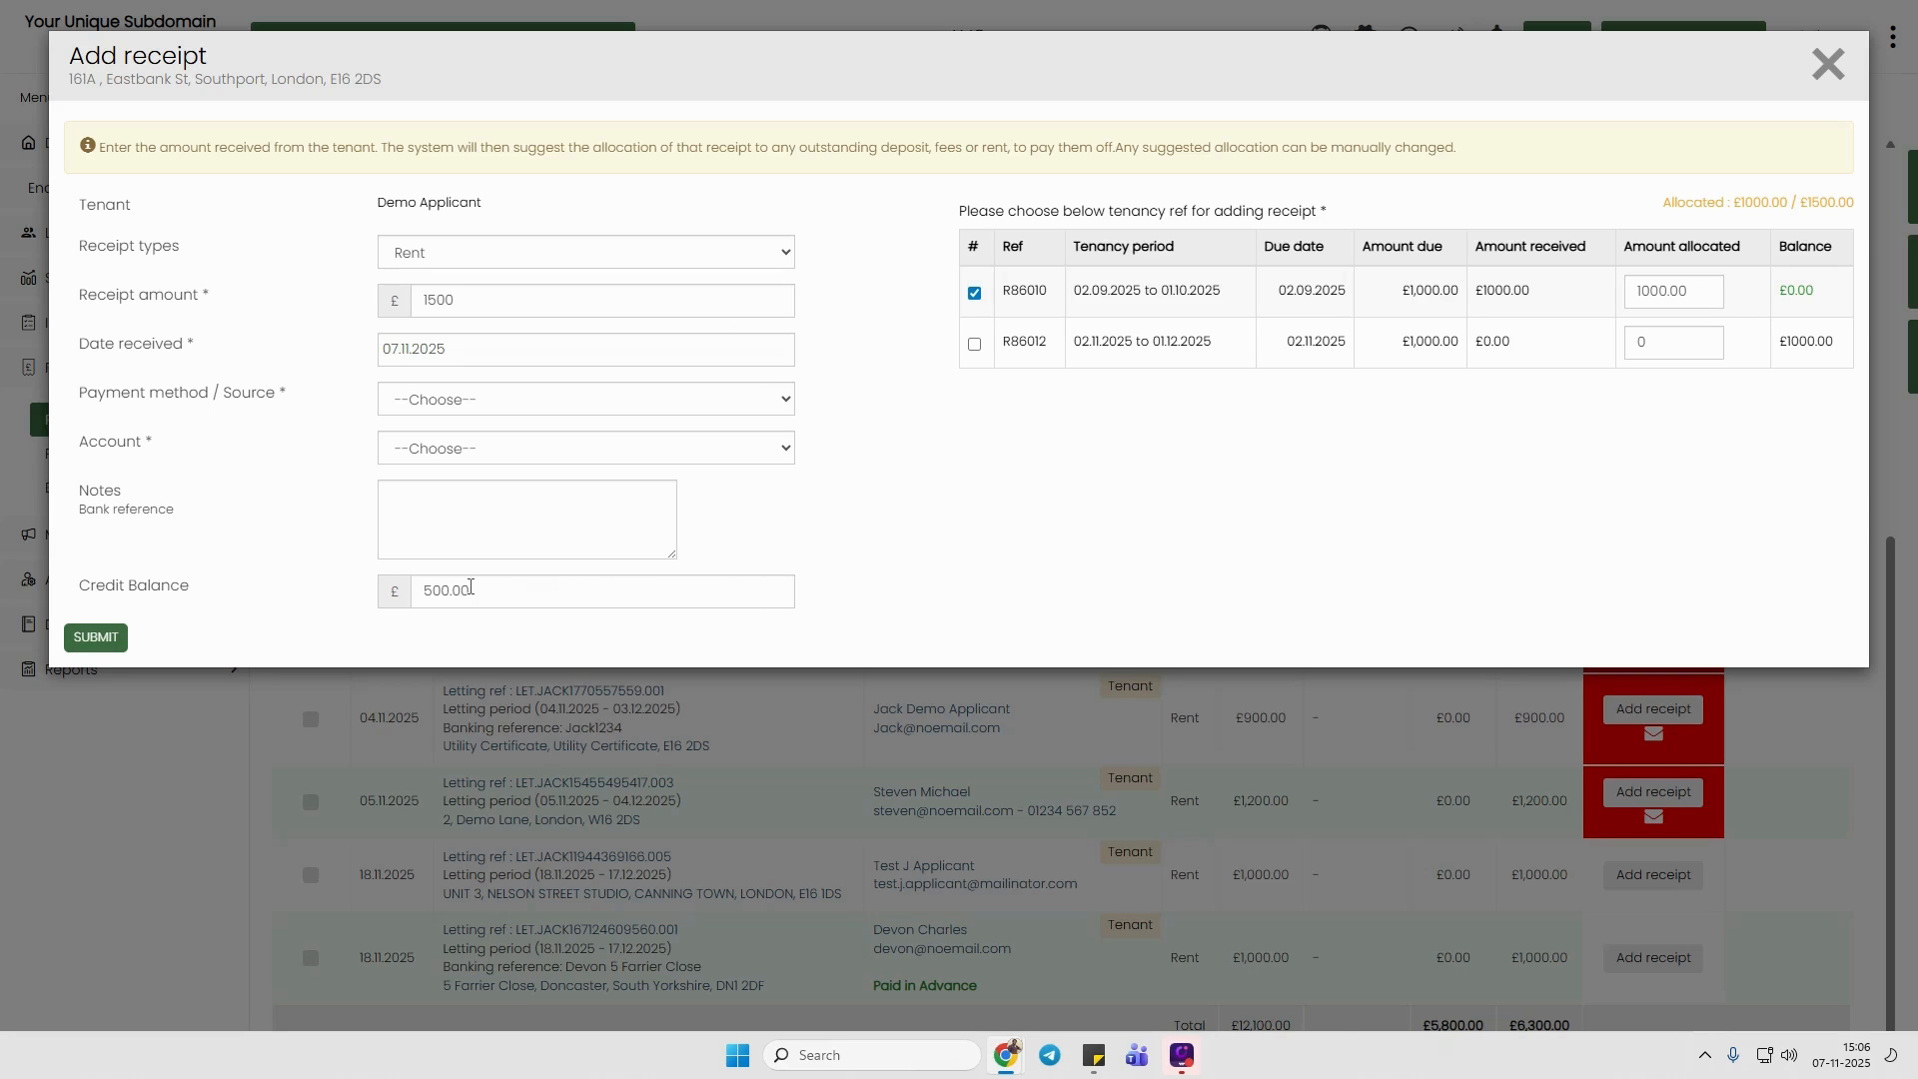

*Figure 12: Receipt of £1,500 entered for a £1,000 period — Credit Balance shows £500.00*

**📌 Note:** Always double-check the 'Allocated' counter (top right of the dialog, e.g. '£1000.00 / £1500.00') to understand how much of the payment has been applied before submitting.

**Step 5: Submit the Receipt**

Once all fields are completed and the correct tenancy period is ticked, click the green SUBMIT button at the bottom-left of the dialog. The system will record the receipt and update the balance for that tenancy period.

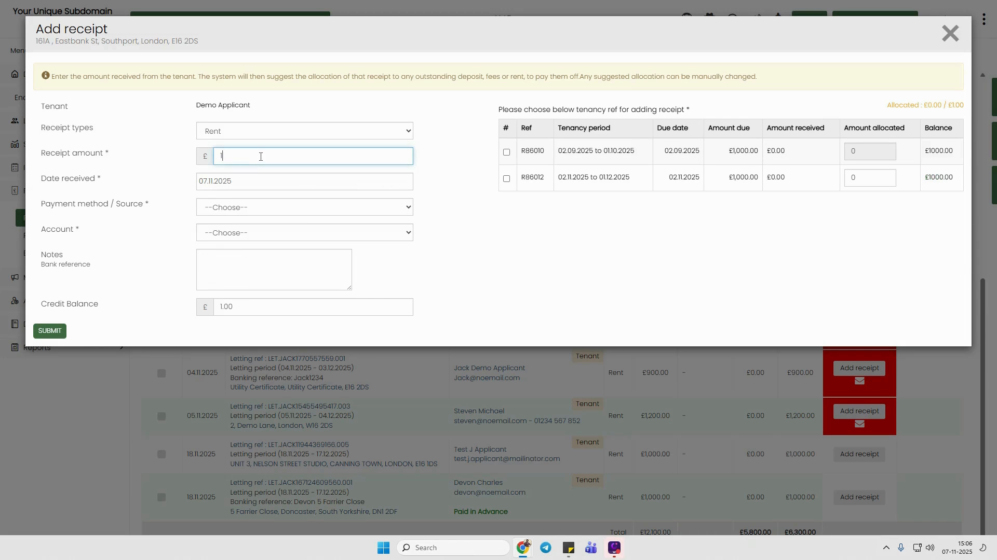

*Figure 13: Completed Add Receipt form ready to submit*

**Step 6: Bulk Mark as Received**

If you need to mark multiple payments as received at once, go back to the Receivables list and tick the checkboxes in the Select All column for each row you want to process. Then click the Mark as received button at the top of the page.

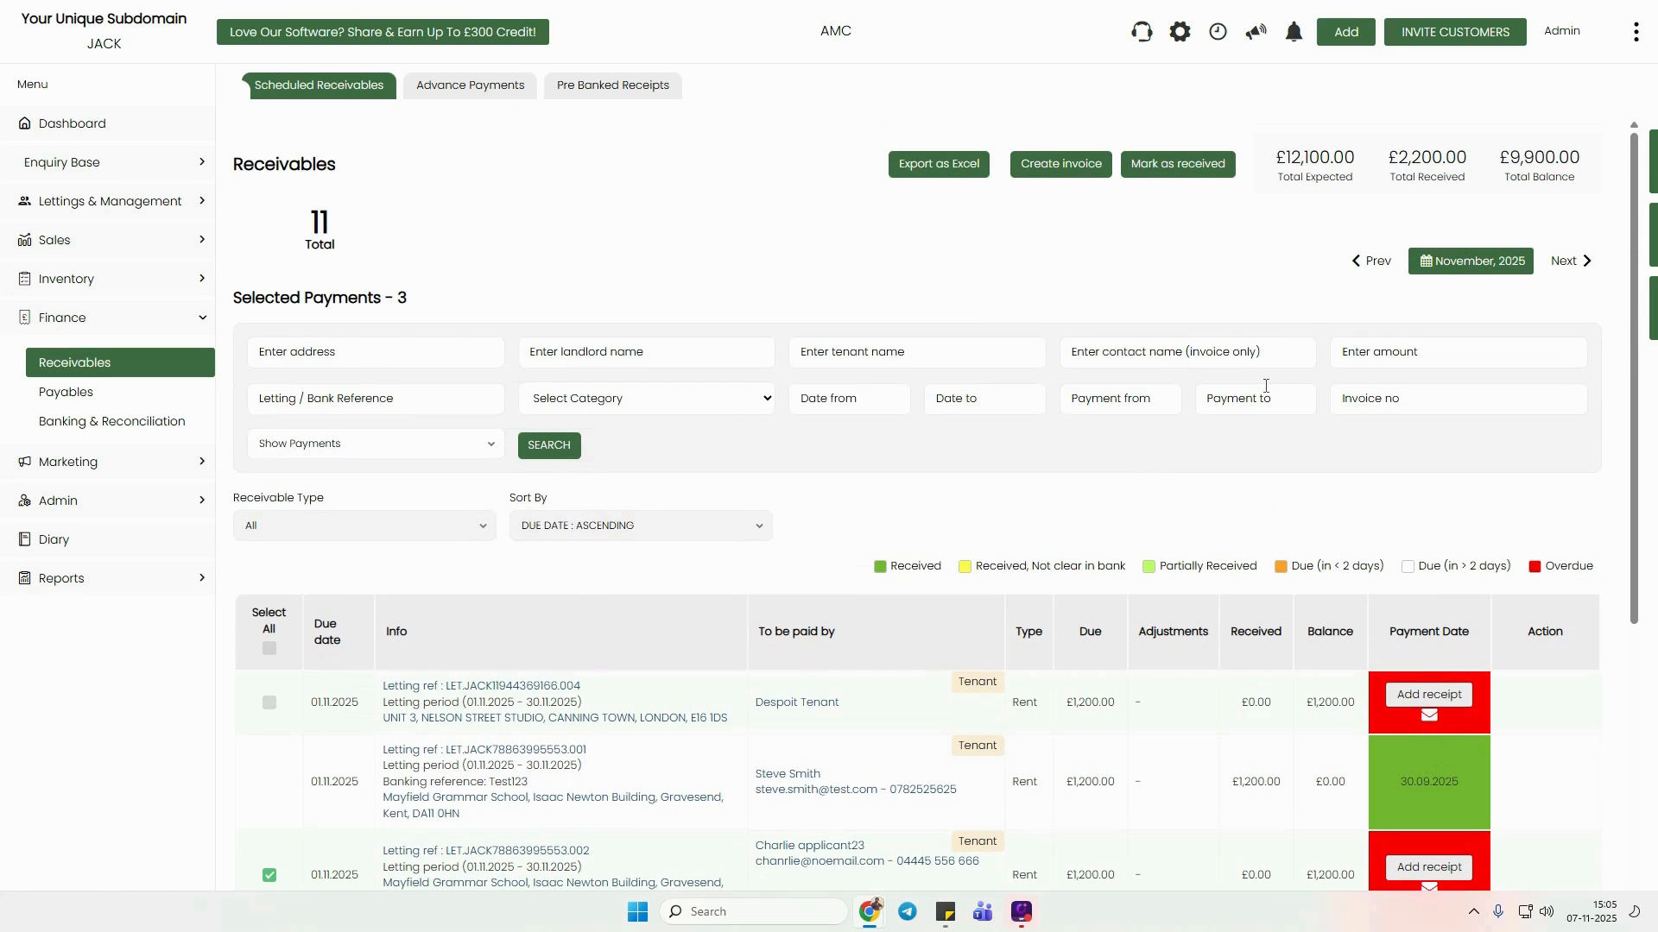

*Figure 14: Multiple rows selected on Receivables page — 'Mark as received' button at the top*

A 'Mark as received' dialog will appear and process the selected records. A progress indicator will show 'Processing X of Y'. Do not close or refresh the page during this process.

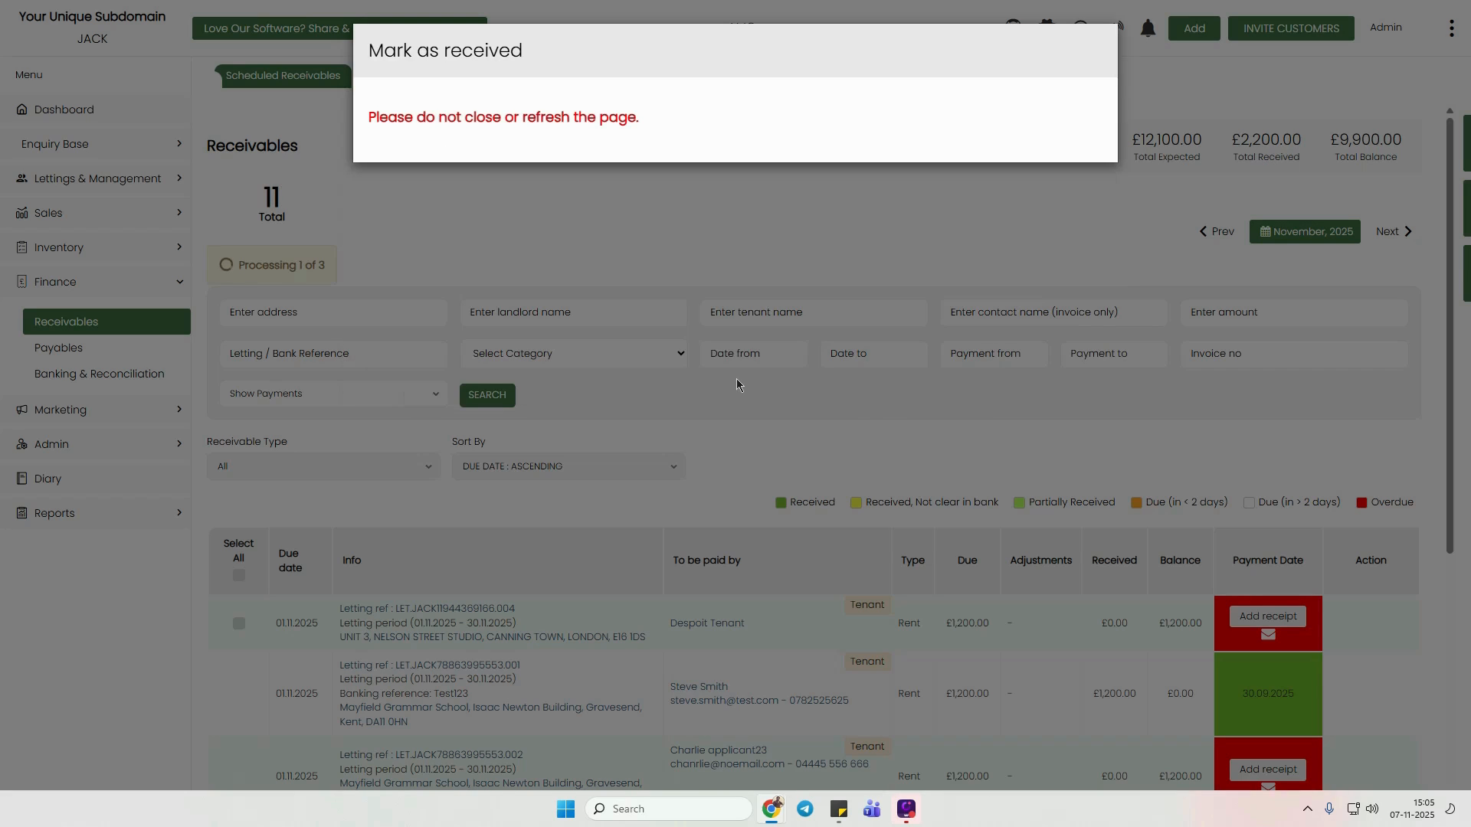

*Figure 15: 'Mark as received' processing dialog — do not close or refresh the page*

# Quick Reference Summary

|  | **Method 1: Bank Statement** | **Method 2: Receivables** |
| --- | --- | --- |
| **Where to start** | Finance → Banking & Reconciliation → Bank Statement | Finance → Receivables → Scheduled Receivables |
| **Best for** | Processing multiple payments from an imported bank file | Manually recording a single payment per tenant |
| **Key action** | Tick transactions + Allocate Transaction | Click Add receipt → fill form → Submit |
| **Bulk processing** | Yes — allocate all ticked transactions at once | Yes — select multiple rows + Mark as received |
| **Overpayment handling** | Shows as Unallocated Amount in Selected Match | Credit Balance field auto-calculates surplus |